Allt Daraich Timber Extraction Facility

Construction, Operation and Decommissioning Environmental Management Plan (CEMP)

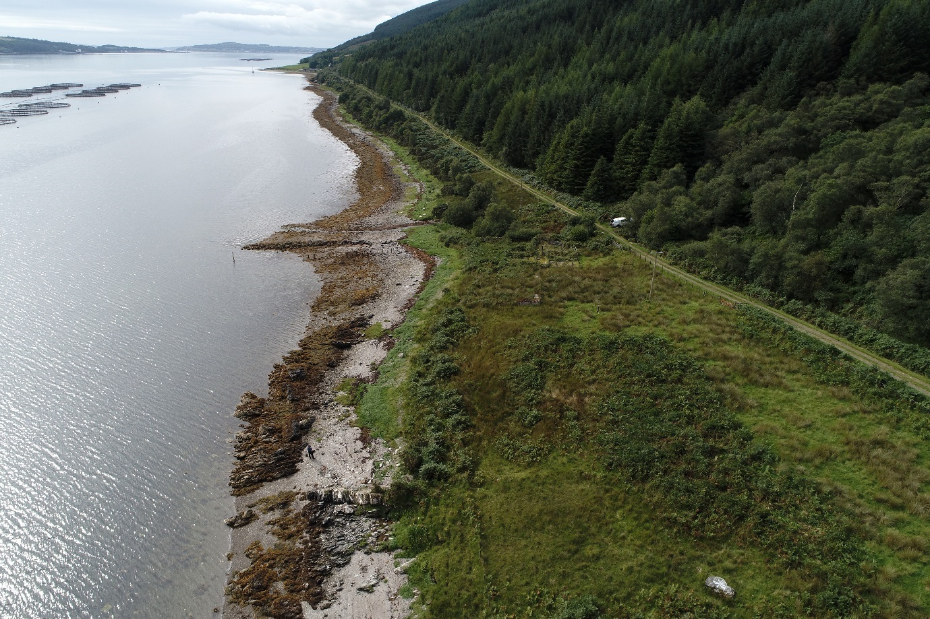

*Plan Prepared by :-*

*Cowal Surveying Services Ltd*

*Wednesday, 07 November 2018– Rev A*

Contents

Introduction 2

Environmental & Ecological Considerations 3

Otter Protection 3

Priority Marine Features & Cetacea 5

Nesting Birds 5

Invasive Non-Native Species 6

Design Consideration 7

Construction Method Statement 8

Principal Contractor Appointment 8

Site-Specific Construction Conditions 9

Temporary Works Compound 10

Working Near Overhead Lines 11

Earthworks 12

Construction SUDS 13

Site Access Arrangements 13

Reinforced Concrete Works 14

Site Waste Management Plan 15

Template Waste Transfer Note 16

Marine Works 18

Accommodation works 18

Installation of Tyre Mattress. 18

Seabed Dive Inspection 18

Operational Method Statement 19

Timber Harvesting 19

Marine Extraction 19

Scottish Salmon Company Conditions 20

Decommissioning Method Statement 21

Removal of the Berthing Ramp 21

Reinstatement of the Access Road and Timber Storage Area 21

# Introduction

It is proposed to construct a berthing ramp on the Western shore of Loch Striven at Allt Daraich. This ramp is designed to accommodate the landing craft Red Princess which is a bow loading vessel capable of carrying a cargo of approximately 800t. It is estimated that 70,000t of timber will be removed from Allt Daraich Forest over the next fifteen years. Indeed this project is crucial to the economic management Allt Daraich Forest, and it is estimated that the felling operation will directly support four full-time forestry operatives and four marine jobs at Troon Tug Co during the fifteen-year felling phase.  Indirect employment opportunities have yet to be adequately assessed. Currently, the only legal access to the forest is via the UC19 fragile public road from Colintraive; this is classified as severely restricted to timber traffic due to a 7.5-tonne bridge weight limit and limited passing places. By facilitating sea transport, it will remove approx. 2,400 HGV loads from the public roads in Cowal which can be seen as a further benefit to the local communities.

This project has Strategic Timber Transport Scheme funding. However, this Forestry Commission operated scheme will cease to exist on 31st March 2019. It is imperative therefore that the Allt Daraich berthing ramp can obtain all of the licences and consents required to progress to the construction phase at the earliest possible opportunity.

A planning application was submitted for the project on 31st Aug with an ePlanning Scotland Reference: 100135586-001. Last December a similar project was proposed for Finnart Point under application reference:- 17/03257/PP. On approval of this application Argyll and Bute Council planning department imposed eleven conditions. Condition 3 stated -

*No development (including any land engineering works or any associated operations) shall commence until a full site-specific Construction, Operation and Decommissioning Environmental Management Plan (CEMP) has been submitted to and approved in writing by the Planning Authority*

It is assumed that the similarity and close proximity of these projects will require the production of project specific CEMP, hence the need for this report.

Further to this, an application will be made to Marine Scotland for a works licence. At Finnart Point this licence was conditionally approved on 1st March 2018 subject to an otter survey being carried out. As a duplication of this requirement, ABC planning condition 4 notes*:- The development shall be implemented in accordance with the mitigation measures identified in the Species Protection Plan (Otter Report dated 10th December 2017).*

Again drawing on the experience from the Finnart Point Project Tillhill Forestry carried out a preliminary ecological appraisal on Sat 1st Sept. A report based on this site inspection is due imminently with the results incorporated into this report by a subsequent revision.

# Environmental & Ecological Considerations

## Otter Protection

Otter surveys conducted as part of the initial site assessment and as part of the pre-commencement checks found no otter resting sites within 30m[1] of the proposed development site. Consequently, otters are not considered to pose a constraint to the works.

However, otters are known to occur along Loch Striven including in proximity to the development site and so there is the potential for individuals to come into close proximity with the construction activities during the works. Consequently, the following general best practice mitigation measures will be implemented to minimise the risk of disturbance, injury or death of otters during the works:

* Toolbox talks will be presented to all construction staff before the commencement of works as part of the site induction. This will include information on the ecology and field signs of otters such as spraints (droppings) and resting sites. This will also include the presence of any sensitive working areas and buffer zones and restrictions within these areas. Also, the Otter Emergency Response Procedure (presented below) will be highlighted to ensure prompt response and correct procedures are followed in the unlikely event of an otter being accidentally killed or injured during the works.
* Access to plant and personnel will be constrained to a prescribed working area through the use of temporary barriers, thereby minimising damage to habitats and reducing potential disturbance effects.
* Unnecessary disturbance to habitats should be avoided by minimising the extent of ground clearance and other construction practices, and by restoring temporary construction and working areas as far as practicable on completion of works.
* It is recommended that night-time working (i.e. defined here as between one before sunset to one hour after sunrise) is avoided. As such, construction activities should be undertaken during daylight hours to avoid the crepuscular (twilight) activity periods of otters. However, if this is not possible and twilight works are necessary, then any artificial lighting will be directed specifically onto the works area for the duration of the active works only. This will be achieved with the use of beam deflectors.
* All trenches and excavations will be fenced off or covered-over at night to prevent any otters (or other animals) from falling in and becoming trapped. If this is not possible an adequate means of escape will be provided (i.e. a gently graded side wall or provision of gently sloped wooden plank or equivalent).
* Any exposed pipes and trenches will be checked for trapped otters (and other wildlife) each morning before starting construction activities.
* Fuel, oil and other chemicals will be correctly stored and sited at least 50m from the loch side.
* Any refuelling of plant/machinery should take place at least 10m from the loch side.
* Speed restrictions on site will be kept to a maximum of 15mph for all vehicles.
* Guidance for Pollution Prevention (GPPs) as available on Netregs’ website[2] will be used to reduce the risk or minimise the impact of any pollution incidents which may occur on site.

Otter Emergency Response Procedure: Plan of Action for Disturbance or Fatality of an Otter During Works

Where any person on site identifies signs that they believe to be of otter, they shall notify an ecologist immediately. If any new features which the contractor suspects may be an otter resting site are discovered within 30m of the proposed works, all contractors will stop work, and an ecologist will be called to attend the site.

In the unlikely event of an otter being trapped, injured or killed during the works, an ecologist will be contacted immediately. They will attend the site and make a written and photographic record. This will record the time, location, personnel involved and details of the incident. This information will be supplied within 24 hours to SNH.

## Priority Marine Features & Cetacea

**Priority Marine Features**

As part of our Finnart Point application and as a consultee to Marine Scotland for the Marine Licence Elizabeth Pryor of SNH noted in her e-mailed comments of 19th Dec 2017: -

*Our records indicate that there may be PMFs present within the vicinity of the development, notably burrowed mud and/or kelp and seaweed communities. There is potential, therefore, for interaction with PMFs, however, in this instance we would advise that impacts are unlikely to be significant with no effect on national status.*

*The applicant, should, however, follow best practice to minimise impacts to sea , particularly during the construction/ decommissioning phases of development but also during the loading of timber and transport.*

It is assumed that this site appraisal will equally apply to Allt Daraich due to the close proximity of the two sites.

**Cetacea**

At Finnart Point the use of sheet piles was proposed as the best solution to deal with the prevailing ground conditions. This raised concerns of possible disruption of cetacea by the transfer of low-frequency noise to Loch Striven from the use of piling hammers. However, at Allt Daraich due to differing ground conditions where rock outcrops cover most of the foreshore, it is assumed that an in-situ reinforced concrete structure would be most suitable. As stressed elsewhere in this plan the berthing ramp is located well above the low water level. Therefore construction works can be carried out as a land-based operation. Careful consideration will be given to the timing and phasing of the works to prevent any chance of tidal wash-out effecting freshly placed concrete. A detailed method statement for concrete works is given on page 13 – 14 of this plan.

## Nesting Birds

As noted earlier, Tillhill Forestry has now carried out a preliminary ecological assessment of the Allt Daraich site. Again, drawing on similar surveys completed recently at Finnart Point it is assumed that for the majority of species the nesting season has now passed. Once Tillhills initial site assessment is available, it will be added to this document as a prudent step to ensuring compliance with the Wildlife and Countryside Act.

## Invasive Non-Native Species

The Cowal Peninsula surfers from the prevalence of various invasive non-native species. In particular Japanese Knotweed, Rhododendron Ponticum, Himalayan Balsam and Montbretia are know to spread vigorously as a result of favouring climatic and ground conditions. It is therefore imperative that the principal contractor for the works develops bio-security measures that prevent the spread of these species. In discharging the planning condition nine at Finnart Point, the principal contractor utilised data sheets available from SEPA and the Forestry Commission to develop a bio-security plan which was part of the site induction information and was also reiterated during subsequent operative tool box talks.

# Design Consideration

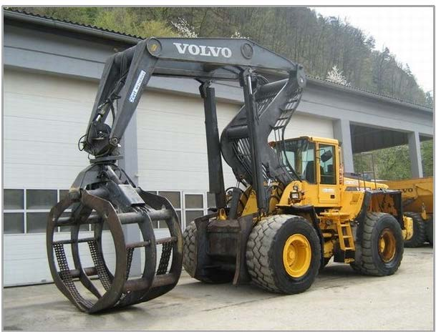In it’s design this ramp must ensure an even gradient from the timber storage area, shown in the layout plan, along the reinforced concrete ramp and onto the deck of the vessel. This even gradient is essential to ensure safe and efficient loading of the vessel, using a large all-terrain wheeled loader – as shown below.

This item of plant has an axle loading of 8.5 metric tonnes. Further structural consideration must be given to the imposed loading applied during the vessel berthing procedure. Allowing for these forces, over the life of the structure, means that the ramp will have to endure a significant amount of stress while the design proposed also aims to minimise maintenance costs. To this end, a structure consisting of in-situ reinforced concrete has been put forward as the best solution.

Fig 1 : Volvo L180H HL – is a bespoke design for log handling.

The ramps location has been specifically chosen about the foreshore topography and to accommodate the bow geometry of the Red Princess – refer berthing profile drawings. A topographical and hydrographical survey of the site has been carried out to assist with this procedure. Further consideration has been given to ensure loading operations can continue during tidal extremes.

Part of the construction works will involve the installation of a tyre mattress. This will be placed at the point on the foreshore where the bow of the Red Princess will intercept the beach. HGV tyres fixed to mooring chains will act as fenders and help to reduce hull damage during loading operations. During this work, the berthing area will be cleared of large boulders or other obstructions. This material will be used during the construction works as rip-rap armour stone which will help to prevent tidal scour when placed around the perimeter of the completed ramp.

# Construction Method Statement

## Principal Contractor Appointment

Under the Construction Design and Management regulations, 2015, Tillhill Forestry acting as the client will appoint a principal contractor. This appointment has an essential role in managing health and safety risks during the construction phase. The principal contractor must have the skills, knowledge, experience and, where relevant, the organisational capability to carry out this work.

Due to the STTS funding requirement, Tillhill Forestry will implement a tender process for the award of these works. This tender process can only commence once all the consents and applications needed for the project have been received. It is hoped that a principal contractor can be appointed and in a position to commence the works by Monday 29th October.

The principal contractor must;-

1. Plan, manage, monitor and coordinate the entire construction phase
2. Take account of the health and safety risks to everyone affected by the work (including members of the public), in planning and managing the measures needed to control them
3. Liaise with the client and [principal designer](http://www.hse.gov.uk/construction/cdm/2015/principal-designers.htm) for the duration of the project to ensure that all risks are effectively managed
4. Prepare a written [construction phase plan](http://www.hse.gov.uk/pubns/cis80.pdf) before the construction phase begins, implement, and then regularly review and revise it to make sure it remains fit for purpose
5. Have ongoing arrangements in place for managing health and safety throughout the construction phase
6. Consult and engage with workers about their health, safety and welfare
7. Ensure suitable welfare facilities are provided from the start and maintained throughout the construction phase.
8. Check that anyone they appoint has the skills, knowledge, experience and, where relevant, the organisational capability to carry out their work safely and without risk to health
9. Ensure all [workers](http://www.hse.gov.uk/construction/cdm/2015/workers.htm) have site-specific inductions and any further information and training they need.
10. Take steps to prevent unauthorised access to the site
11. Liaise with the principal designer to share any information relevant to the planning, management, monitoring and coordination of the pre-construction phase.
12. Develop a site-specific waste management plan. The operation of this plan will be part of the pre-start operative toolbox talk. The complete plan has been added in page 15.

## Site-Specific Construction Conditions

As a result of pre-commencement planning conditions, the principal contractor must also comply with some site-specific constraints. Thes are:-

1. Working time restrictions will be imposed by planning condition. The principal contractor should ensure that no work is undertaken outwith these time restrictions.
2. Organising the works in such a manner as to reduce the effect of noise and vibration on adjacent properties. The principal contractor's site manager will provide contact details to local residents so that the manager will be the first point of contact.
3. Implement a regular dialogue between the site manager and Scottish Salmon Company (SSC) Regional Manager regarding the start and progress of construction. It is proposed that this dialogue should be in the form of a weekly email.
4. Provide SSC with a works programme in Gantt chart format which details the duration of the primary construction activities. Individual tasks should be allocated where vessel movements are required for the delivery of plant or materials.
5. In addition to measures required in the pollution response plan, the principal contractor must notify SSC of any environmental incidents (e.g. spills or elevated sedimentation) at their earliest possible convenience, but no later than one hour of the incident taking place.

## Temporary Works Compound

In the initial stage of the contract a Groundhog welfare van or equivalent will be located onsite within the works outline. These welfare units are fully portable, CDM compliant and secure. Serviced with potable water and a generator supplied 240v power supply the welfare unit will be moved around the site to accommodate the best location as required by the progress of the works. The principal contractor will ensure that any welfare facilities will not hinder access or egress to the adjacent access road to Braingortan. The works area will be fenced and will also allow for:-

1. Storage – all equipment, materials and chemicals will be stored away from any watercourse and outside relevant buffer zones. Chemical, fuel and oil stores will be sited on impervious bases in accordance with PPG2 and within a secured bund of 110% of the storage capacity, within the laydown area;
2. Vehicles and refuelling – standing machinery will have drip trays placed underneath to prevent oil and fuel leaks causing pollution. Where practicable, refuelling of vehicles and machinery will be carried out on an impermeable surface in designated areas, well away from any watercourse, or drainage ditches, and will adhere to best practice as detailed in PPG7;
3. Maintenance – Plant and machinery used during the construction phase will be well maintained to minimise the risks of oil leaks or similar. Maintenance to construction plant will not be permitted on site, unless vehicles have broken down necessitating maintenance at the point of breakdown. All necessary pollution prevention measures will be put in place prior to commencement of maintenance in this instance; and
4. Pollution response – A detailed pollution response plan will be developed for the site. Spill kits will be held in each item of plant and also be easily accessible on site.

## Working Near Overhead Lines

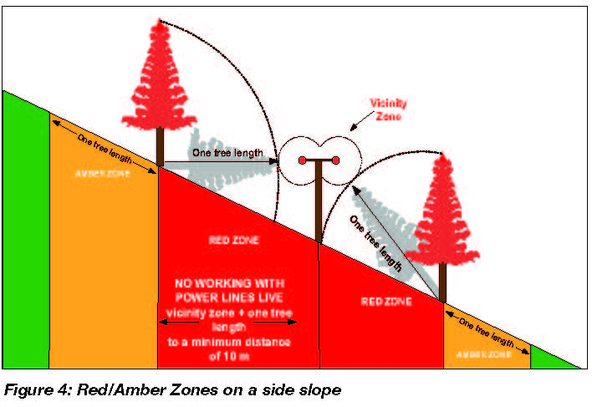Special consideration has been given to the design of this facility to accommodate a safe working distance from the existing 15KV overhead line. Forestry Industry Safety Accord guidance note 804 – fig 4 and HSE guidance note GS6 was the basis for the timber stacking areas orientation in relation to the overhead line.

This line supplies the property of Braingortan and all the nearby properties adjoining the UC19 coastal route toward Colintraive. It is envisaged that the principal contractor will develop toolbox talks in conjunction with risk assessments and method statements to manage the risk of work in the vicinity of this overhead line.

Early consultation will be arranged by Tillhill Forest with the Scottish and Southern Energy to further establish control measures that may need to be implemented for the work . It is envisaged that SSE will require a watchman and the use of an excavator fitted with height restriction equipment to allow the construction of the section of access road that passes directly under the power lines.

The principal contractor will also install suitable height restriction barriers to prevent construction plant straying outside the designated safe working zone.



## Earthworks

The first construction activity will be to upgrade the existing access track and create the timber storage area. This will be completed by stripping away the topsoil or unsuitable material, using a hydraulic excavator and a 10t dumper. Topsoil and sub-soil material will be deposited onsite in a perimeter bund, thus helping to screen the work. The proximity of these bunds, to the working area, will assist in speeding up the excavation and prevent an excessive amount of construction traffic using the adjacent public road. Also, remediation of the site will be a far more efficient operation with the storage of all arisings in-situ. Further to this, keeping topsoil and sub-soil onsite is seen as a prudent step in maintaining biosecurity and preventing the spread of invasive non-native plant species.

To ensure compliance with the Guidance on Pollution Prevention, the following silt mitigation procedures should be undertaken during the earthworks operation

1. The requirement to cover clays with topsoil to prevent wash off of fine sediments.

2. Provision of sediment traps downslope of stockpiled material until such times as potential for silt loading has reduced, and vegetation has established.

3. Progress of any earthworks should cease in periods of heavy rainfall where silt-laden runoff is likey.

4. Careful consideration should also be given to the amount of dust generated during dry weather periods. The normal method of dust control applied is spraying the affected area with water using a tractor towed bowser.

The exposed sub-soil formation will then be coated with a suitable amount of crushed stone. This material will be gained from a borrow pit within Allt Daraich Forest.

Once the access road and storage area have been completed, an access route to the foreshore will be undertaken. The location of the berthing ramp will then be accurately set out to establish its perimeter. There is an existing rock outcrop at the chosen ramp location, so a bench, 750mm wide will be excavated by pneumatic percussion rock hammers along this perimeter. The purpose of this excavation work is to allow a uniform level and therefore ease the installation of an in-situ reinforced concrete wall. This wall will form the vertical face of the berthing ramp and subsequently support the installation to the deck slab.

## Construction SUDS

Once the bulk earthworks have been completed the site drainage will be installed in accordance with the drainage layout drawing J900TF05 -Rev0. The drainage design at Allt Daraich has been prepared in conjunction with guidance given in both the Guidance on Pollution Prevention (GPP5) and The Water Environment (Controlled Activities) (Scotland) Regulations 2011. The principals of silt removal utilised:-

1. Filtration of water through filter media (example - stone check dam).
2. Filtration/settlement of water across the undisturbed vegetated ground.
3. Detention/settlement in settlement ponds or behind check dam in swales.
4. Conveyance of shallow depths of water in the vegetated swale.
5. The use of proprietary filter netting

The first item of drainage works to be carried out will be to install a culvert on the existing burn. This burn is approximately two metres deep and has to be crossed by the new access route. It is proposed that a 1500mm diameter twinwall plastic culvert will be installed. This will be laid at such a line and level to allow this existing drainage route to be kept separate from surface water discharging from earthworks area. It is also envisaged that a 1500mm culvert can be installed at a level that will allow natural bed material to accumulate above the pipes invert level. Once completed the new access route will have splash guards fitted, comprising of proprietary filter netting. These will be located on either side of the road for an appropriate length on the approach to this culvert.

New drains will be constructed complete with check dams to assist in silt removal. Surface water outfalls will also have silt traps or ponds in conjunction with silt fencing to further reduce the amount of silt discharged. To help with this silt mitigation philosophy, standard construction procedure will prevent bulk earthworks or drainage excavation activities proceeding in periods of heavy rainfall. The works manager will, therefore, coordinate all earthwork operations in conjunction with suitable weather conditions.

## Site Access Arrangements

The existing access road to Allt Daraich is only suitable for light goods vehicles. It is therefore proposed that all construction plant and materials, which breaches the imposed U19 weight restriction of 7.5t, will be delivered by sea. Either the adjacent Finnart Point berthing ramp or the Tank Slip at Kames, near Tighnabruaich, will be used as the loading point for this activity. The marine delivery of plant and materials will be arranged with Robin Taylor at Troon Tug Co Ltd.

## Reinforced Concrete Works

As part of the bulk earthworks, the rock outcrop at the berthing ramp location will have a bench cut into it, by rock hammers fitted to a fourteen-tonne excavator. This bench will follow the perimeter of the berthing ramp and facilitate the installation of a in-situ reinforced concrete wall. This wall will be 300mm thick and will in conjunction with the retained selected suitable infill and internal ground beams support the loading applied by the deck slab. Reinforcing starter bars will be drilled into the rock and then resin anchored to form a secure bond between the new structure and the underlying rock strata.

On completion of the perimeter wall an internal ground beam will be formed. These beam will sub-divide the span of the deck slab and therfore more evenly transfer loading to the rock foundation below. Only no fines crushed stone will be used to fill the void above the rock outcrop and the soffit of the deck slab.

Shuttering or formwork can now be set up to allow the deck slab to be constructed. C35 ready-mixed concrete with A252 mesh reinforcement shall be used with the slab being 250mm thick and covering an area of 140m2.

Washout of concrete trucks shall only be undertaken in the designated area specified in the drainage layout plan. No surface run-off from within the washout area shall be permitted to leave and directly enter any adjacent drain or watercourse. Wash water shall be contained within a lined containment lagoon or equivalent sufficient to contain all liquid and concrete waste generated by washout operations.

Surplus water from the wash pit may be reused for truck washing. When temporary concrete washout facilities are no longer required for the work, any hardened concrete should be removed and disposed of offsite or by burying in existing excavations on site. Residual liquor shall be removed off-site for treatment or licensed disposal appropriate to the degree of contamination.

It is anticipated that all construction materials will be delivered by Troon Tug Co’s landing craft. Cement will be delivered in 1.5t pallets made up of 25kg bags. These will be stored onsite in a designated sealed container for the duration of the concrete works.

The estimated overall duration of the construction works is 6 – 8 weeks.

## Site Waste Management Plan

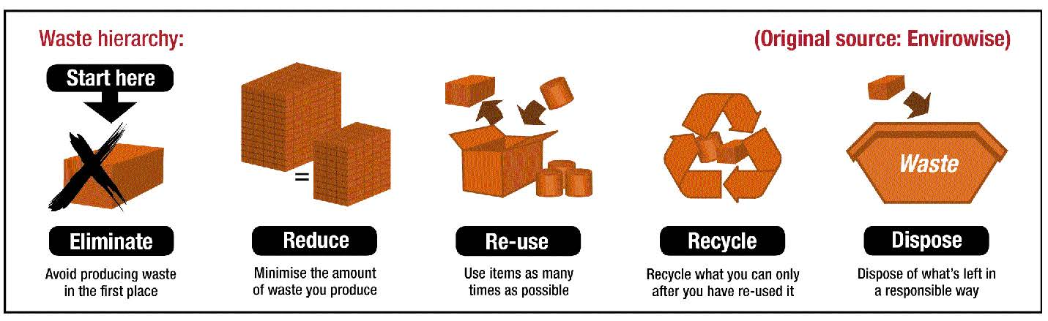A Site Waste Management Plan (SWMP) set how resources will be managed and waste controlled at all stages during a construction project. The above diagram helps to define the main aim of a SWMP. Although more pertinent to a building or civil engineering project, where large volumes of waste are generated, it displays good environmental husbandry to relate waste planning to all forestry work.

Table two details the pre-contract waste management plan for the works for Allt Daraich. A copy of a template waste transfer note has also been added to the appendix of this plan.

**Table 2 – Allt Daraich SWMP**

|  |  |  |
| --- | --- | --- |
| **Item No** | **Requirement** | **Nominated Person or Action** |
| 1 | **Who** will be responsible for resource management. | A McCrae will nominate a site operative or supervisor to be responsible for onsite resource management. At Finnart Point Alistair McCrae will be the director responsible for the work and Kevin Nixon will be the site supervisor. |
| 2 | **What** types of waste will be generated. | Waste survey to be carried out by the resource management officer prior to the pre-commencement meeting. |
| 3 | **How** the waste will be managed – will it be reduced, reused or recycled? | The survey will make best effort to reuse all materials from the site. Waste engine and hydraulic oil will be recycled by a licenced facility. Grease cartridges and filters will be disposed be removed from site in sealing containers and disposed of. Left over timber will be reused . |
| 4 | **Which** contractors will be used to ensure the waste is correctly recycled or disposed of responsibly and legally. | A&L McCrae will ensure that all waste is correctly recycled or disposed of responsibly and legally. |
| 5 | **How** the quantity of waste generated by the project will be measured. | Quantities will be confirmed in the pre-commencement survey. |

## Template Waste Transfer Note

|  |  |  |  |
| --- | --- | --- | --- |
| Template Duty of Care - Waste Transfer Note | | | |
| **Description of Waste** | | | |
| Description of waste to be transferred: |  | | |
| How is the waste contained | Loose: bags: skip: drum: other……………………………… | | |
| Quantity: Number of bags/sacks, weight |  | | |
| **Current holder of the waste (the Transferor)** | | | |
| Name / Company: | Address: | | |
| Which of the following are you? | Waste producer | Holder of waste disposal or waste management licence | Licence No………………  Issued by…………………. |
| Waste Importer | Exempt from licence requirement | Give reason: |
| Waste collection Authority | Registered waste carrier | Registration No…………….  Issued by…………………… |
| **Person collecting the waste (the Transferee)** | | | |
| Name / Company: | Address: | | |
| Which of the following are you? | Waste collection Authority | Authorised for transport purposes | Specify which……………………….. |
|  | Holder of waste disposal or waste management licence | Licence No………………  Issued by…………………. |
|  | Registered waste carrier | Registration No…………….  Issued by…………………… |
|  | Exempt from licence requirement | Give reason: |
| **Address of transfer/collection point** | | | |
| Address: | | Date of transfer: | Time of transfer: |
| Name and address of broker (if applicable): | |  | |
| Name of Transferor:  Company:  Signature: |  | Name of Transferee:  Company:  Signature: |  |

It is required that the principal contractor will have a SEPA waste management licence.

# Marine Works

## Accommodation works

It is envisaged that the seabed will require some reprofiling and boulder removal. This work will be carried out by an excavator which will be guided and assisted by a team of divers. Once removed all oversized stone will be incorporated into the permanent works as rip-rap armour. Campbell Marine has been appointed to carry out the seabed accommodation works. They will also assist Troon Tug Co Ltd to prepare the necessary materials to assemble the tyre mattress and transport it to the site.

## Installation of Tyre Mattress.

The final construction operation will be to prepare and install a tyre mattress. During our consultation with Marine Scotland for the Finnart Point project, SEPA requested that Troon Tug Co obtain a waste exemption for the use of HGV tyres in the mattress. Details of this are:-

Your notification for an exempt activity under the Waste Management Licensing (Scotland) Regulations 2011 has been successfully registered by SEPA.

Your Waste Exemption number is: WML/XS/1166143.

If you have any queries or issues with your registration, please contact the West Highlands & Argyll team on 01397 704426 quoting your Waste Exemption number.

Please find below a summary of your registration:

Further construction details will be requested from Campbell Marine about this activity.

## Seabed Dive Inspection

Once the mattress has been completed a dive inspection of the seabed will be carried out. Again this work has been awarded to Campbell Marine. A detailed method statement will be provided for this item of work and subsequently added to this report.

# Operational Method Statement

## Timber Harvesting

Felled timber will be transported from Allt Daraich forest over the existing forest road network. It is estimated that 70,000tonnes of timber will be extracted during the proposed felling phase of the forest management plan. The timber storage area at Allt Daraich is designed to store approximately 1600t of timber and safely allow the HGV to turn without manoeuvring on the adjacent access track.

## Marine Extraction

Fig 3 :- The Red Princess waiting for high tide to depart.

The Red Baroness is designed to carry 800t of timber per load. Arriving and departing from the berthing ramp at high tide, loading is quickly undertaken in the low tide period when the vessel is aground.

## Scottish Salmon Company Conditions

As part of the planning consultation period for the Finnart Point site, Scottish Salmon Company (SSC) raised a concern about the likelihood of logs falling into the water. In response to this concern Robin Taylor of Troon Tug Co Ltd suggested that the Red Princess carried a dinghy and in the unlikely event that a log did fall into the water, the dinghy would be launched to recover it.

As part of the further consultation with Troon Tug Co about the use the Allt Daraich site, Penny Hawdon, Scottish Salmon Environmental Project Co-ordinator, also supplied mobile phone numbers and radio call signs for the managers that operate their near-by Sgian Dubh barge and cages. Penny suggested that if any retrieval operation was required that the Sgian Dubh barge manager should be made aware of it. Troon Tug Co accepted this proposal and incorporated it into their method statement for operating at this facility.

In addition to this, a planning condition was imposed upon the marine operation of this site. This condition requested that all vessel movements to the Allt Daraich berth be notified in advance to SSC. As mentioned earlier, Troon Tug Company have the contact details to relay this information directly with the Sgian Dubh barge manager. This constraint has been imposed by planning condition and to discharge it, Troon Tug Company will revise their site method statement accordingly.

Tillhill Forestry will also consult with SSC’s regional manager about the longer-term programme for vessel movements in relation to the prosed Allt Daraich timber harvesting plan.

# Decommissioning Method Statement

## Removal of the Berthing Ramp

Once forest operation has been completed the main structural element of the berthing ramp will be carefully removed for use elsewhere. The in-situ concrete structure will be cut into sections, that can be safely lifted, and transported to another site. The area of foreshore which the ramp occupied will be graded back to the natural level. It is estimated that the design life concrete structure will be twenty-five years due to the berthings ramps limited daily tidal immersions. Also, a system of anodes may be installed to the rebar to ensure that corrosion rates are minimal at the point of decommissioning.

## Reinstatement of the Access Road and Timber Storage Area

All earthwork arisings from the construction of the timber stacking area and access road will be stored onsite. Once the ramp has been decommissioned the onsite storage areas will be excavated and deposited in a manner which will reinstate the area to the pre-start topography while also depositing the correct depth of topsoil. Topsoil will be stripped and stored in separate bunds to allow it to be correctly distributed around the site. A suitable grass seed with an appropriate blend of wildflowers will be spread over the newly placed topsoil areas to speed up revegetation of the reinstated areas.

1. 30m is the critical within which a European Protected Species (EPS) development licence for otter is typically required from SNH.
2.